**An IOT based Personal Health card**

*A Thesis/Project Submitted in Partial Fulfillment of the Requirements for the*

*Degree of*

Bachelor of Science in Computer Science and Engineering

*by*

**Md. Humayun Kobir**

CSE06107313

&

**Rafid Tawhid**

CSE06107311

Supervised by: Ahmed Abdal Shafi Rasel

(Senior Lecturer)

|  |
| --- |
| C:\Users\Adnan\Desktop\1.jpg |

Department of Computer Science and Engineering

STAMFORD UNIVERSITY BANGLADESH

June 2020

**Abstract**

Abstract text here…

**Approval**

The project report “Thesis/Project Report name” submitted by STUDENTNAME ID: STUDENT_ID, STUDENTNAME ID: STUDENT_ID, to the Department of Computer Science & Engineering, has been accepted as satisfactory for the partial fulfillment of the requirements for the degree of Bachelor of Science (B.Sc.) in Computer Science & Engineering and as to its style and contents.

Board of Examiner’s Name, Signature and Date:

|  |  |  |
| --- | --- | --- |
| **……………………………...** | **……………………………..** | **……………………………..** |
|  |  |  |
| **(Board Member 1)** | **(Board Member 2)** | **(Board Member 3)** |
| Date: | Date: | Date: |

Supervisor’s Signature and Date:

**……………………………...**

**Supervisor Name**

Date:

**Declaration**

We, hereby, declare that the work presented in this Thesis / Project is the outcome of the investigation performed by us under the supervision of Supervisor Name, Supervisor Designation, Department of Computer Science \& Engineering, Stamford University Bangladesh. We also declare that no part of this Project and thereof has been or is being submitted elsewhere for the award of any degree or Diploma.

Signature and Date:

**……………………………...**

**Student Name:**

Date:

**……………………………...**

**Student Name:**

Date:

Dedicated to…

**Acknowledgements**

Acknowledgement text here...

**Table of Contents**

List of Figures 1

List of Tables 2

1: Introduction 3

1.1 Motivation 3

1.2 Sensors 3

1.2.1 Thermostats and HVAC controls 3

1.2.2 Example Figure: 4

1.2.3 Example Referencing 4

1.3 Chapter Summary 4

2: Literature Review 5

2.1 Background Study 5

2.1.1 Android Based Home Automation 5

2.2 Chapter Summary 5

3: System Design 6

3.1.1 Pin Definition 6

3.1 Parameter 6

3.2 Chapter Summary 8

4: Implementation 9

4.1 Implementation 9

4.1.1 Configuration Code 9

4.2 Chapter Summary 10

5: Conclusion 11

5.1 Limitations 11

5.2 Future Work 11

References 12

# List of Figures

1.1 NodeMCU Microcontroller 4

2.1: Android based Home Automation System 5

3.1: Pin Definition of NodeMCU 6

# List of Tables

3.1: Pin Description of NodeMCU 7

3.2: Parameters of NodeMCU 7

# Introduction

The effect of information and latest automation technology is manifesting more and more widely in medical strategy, bringing substantial benefits to the health and welfare of all patients.

Data processing is one of the crucial aspect for any patient. Actually health management and control systems are based on transmitting and comparing a large amount of data, information and variation of knowledge.

This obstacle enhanced the need for an accurate and efficient flow of patient medical information between organizationally and geographically distinct providers. However, patient data may not be available in some situations, either because the infrastructure is inaccessible or may be in an accident

where there is no way to link the patient to the infrastructure (e.g. the patient cannot supply all necessary identification information).In that situation the patient could give the wrong diagnosis so that the patient may receive inappropriate treatment.  
in the case of an emergency situation in an accident injured or sick person, it is essential to obtain timely patient's past medical history in order to prevent the supply of incorrect treatments which could further aggravate the situation.

The importance of having the medical history of patients is absolute to speed up the healing process and reduce many risk or health issues .Consider, for example, if a patient admitted urgently to a hospital and no one know or don’t have any reports of all the sensitive information needed before surgery, then he should be first subjected to a series of investigations and then go for surgery or other medical treatment.

Now a days, in almost every country in the world, substantial financial resources to their health care sector

The use of statistics technological know-how has grown to be not unusual in healthcare. The internet. (Dayyala Sunitha, D.SreeHari, November 2015)and telecommunication applied sciences are normally recognized to make a contribution to the improvement of countrywide fitness care machine infrastructureand beautify the extension of international markets for healthcare offerings.  
In emergency situations, due to the fact that most Emergency Medical Services (EMS) and fitness carrier services which include hospitals, auxiliary care facilities and public fitness departments use disparate records science systems, real-time records is virtually not possible to be shared.

There is growing concern about maintaining one's health as population ages, sensor or automated smart technology are expected to provide real-time information about health condition or many more such things which needed if there is an emergency situation.

This obstacle enhanced the need for an accurate and efficient flow of patient medical information between organizationally and geographically distinct providers. However, patient data may not be available in some situations, either because the infrastructure is inaccessible or may be in an accident

where there is no way to link the patient to the infrastructure (e.g. the patient cannot supply all necessary identification information).In that situation the patient could give the wrong diagnosis so that the patient may receive inappropriate treatment.

We propose a radio frequency identification (RFID)-based community e-health system where a patient is given a “passive” RFID card and the people holding a specific mobile app can read some emergency data when needed this device that can also access the central electronic medical record system. It may also help to improve the efficiency of the general medical facility.

(Here we propose to use an RFID tag to store all important & necessary health information like previous drug administration, medications, restrictions in food and allergies ,sensitivities, current treatment, medical history, and contact of family members. We know that detailed health information is very crucial for the emergency case to take the right medical decisions and proper treatment. If we get the patient’s personal health record easily in that situations it may help prevent costly drug events and primary test to know previously diagnosed medical conditions which reduce medical errors.. In short this solution will be smooth and speed up the diagnostic assessment. If we get access to patient information it may improve the ability to give the proper medical treatment in emergency situations.)

The goal of this RFID-based personal healthcare app is to enable easy and reliable identification solution of any patients in case of emergency, it may maintain medical records more accurately and digitalized the life in communities.

## Motivation

Motivation text here…

## Sensors

1. ESP8266 12E wi-fi/Node MCU
2. 4/8/16 channel Relay Board
3. USB TTL Serial Adapter
4. PIR Motion sensors

### Thermostats and HVAC controls

Common thermostats and HVAC controls are:

* Humidity sensing and control
* Temperature sensors and controllers
* Weather stations and sensors

### Example Figure:

An example figure insertion is presented in Figure 1.1.

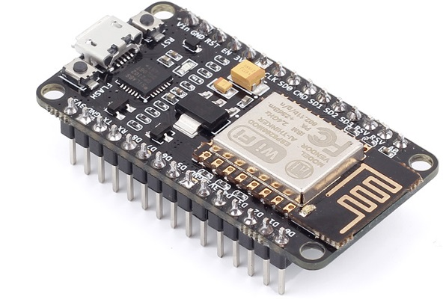

Figure 1.1 NodeMCU Microcontroller

### Example Referencing

An example of inserting references in word [1][2].

## Chapter Summary

In this chapter, ....

# Literature Review

Chapter introductory text here ...

## Background Study

Refer all background study like here [3]. Few more references inserted here [4][5]. Web sites can also be put as reference like here [6].

### Android Based Home Automation

An example of Android-based home automation system [7] is presented in Figure 2.1.

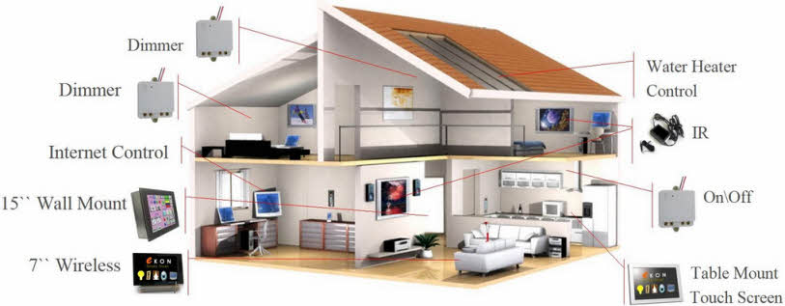

Figure 2.1: Android based Home Automation System

## Chapter Summary

In this chapter, ...

# System Design

Chapter introductory text here ...

### Pin Definition

In the Figure 3.1, the pin definition of NodeMCU [8] is shown and in the Table 3.1 a detailed pin description is given.

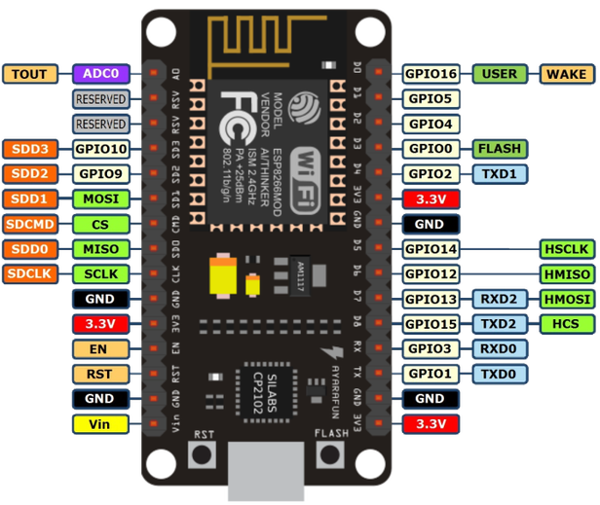

Figure 3.1: Pin Definition of NodeMCU

## Parameter

The NodeMCU parameters are listed in Table 3.2.

Table 3.1: Pin Description of NodeMCU

|  |  |  |  |
| --- | --- | --- | --- |
| Pin | Name | Type | Function |
| 1 | VDDA | P | RF Antenna Interface. Chip Output Impedance=50Ω No matching required but we recommend that the π-type matching network is retained. |
| 2 | LNA | I/O | Analog Power 3.02 ~ 3.6 V |
| 3 | VDD3P3 | P | Analog Power 3.02 ~ 3.6 V |
| 4 | VDD3P3 | P | Analog Power 3.02 ~ 3.6 V |
| 5 | VDD3P3 | P | Analog Power 3.02 ~ 3.6 V |
| 6 | ... | … | … |

Table 3.2: Parameters of NodeMCU

|  |  |  |
| --- | --- | --- |
| Categories | Items | Values |
| Wi-Fi Parameters | certificates | FCC/CE/TELEC/SRRC |
| WiFi Protocols | 802.11 b/g/n |
| Frequency Range | 2.4G-2.5G (2400M-2483.5M) |
| TX Power | 802.11 b: +20 dBm |
| 802.11 g: +17 dBm |
| 802.11 n: +14 dBm |
| RX Sensitivity | 802.11 b: -91 dbm |
| 802.11 g: -75 dbm (54 Mbps) |
| 802.11 n: -72 dbm (MCS7) |
| Types of Antenna | PCB Trace, External, IPEX Connector, Ceramic Chip |
| Hardware Parameters | TX Power | UART/SDIO/SPI/I2C/  I2S/IR Remote Control |
| GPIO/PWM |
| Operating Voltage | 3.0~3.6V |
| Operating Current | Average value: 80mA |
| Operating Temperature Range | -40°~125° |
| Ambient Temperature Range | Normal temperature |
| Package Size | 5x5mm |
| External Interface | N/A |

## Chapter Summary

In this chapter, ...

# Implementation

Chapter introductory text here ...

## Implementation

…

### Configuration Code

Sample configuration code is presented in

**#define** BLYNK_PRINT Serial

**#include** <ESP8266WiFi.h>

**#include** <BlynkSimpleEsp8266.h>

**char** auth[] = "YourAuthToken";

**char** ssid[] = "YourNetworkName";

**char** pass[] = "YourPassword";

**void** setup()

{

Serial.begin(115200);

Blynk.begin(auth, ssid, pass);

}

**void** loop()

{ Blynk.run(); }

Listing 4.1: NodeMCU Configuration Code

## Chapter Summary

In this chapter, ...

# Conclusion

Conclusion text here ...

## Limitations

...

## Future Work

...

# References

1. D. Pishva, "Internet of Things: Security and privacy issues and possible solution" in *2017 19th International Conference on Advanced Communication Technology (ICACT)*, Feb 2017 pp. 797-808.
2. S. Tale, A. Kakad, N. Bhawarkar, D. Patil, and P. Nimat, “Control System for Home Automation based on IoT”, *Proceedings of the National Conference on Innovative Trends in Science and Engineering*, ser. NC-ITSE'16, vol. 4, num. 7, 2016, pp. 324-326.
3. A. ElShafee and K.A. Hamed, “Design and implementation of a WIFI based home automation system”, *World academy of science, engineering and technology*, vol. 68, pp. 2177--2180, 2012.
4. R. Harper, *Inside the smart home,* Springer and Business Media, 2006.
5. G. Mois, S. Folea and T. Sanislav, "Analysis of Three IoT-Based Wireless Sensors for Environmental Monitoring", *IEEE Transactions on Instrumentation and Measurement*, vol. PP, no. 99, pp. 1-9, 2017.
6. Arduino, “Arduino IDE”, [Online]. Available: https://www.arduino.cc/.
7. Tarun Agarwal, "Android Based Home Automation Systems and its Applications", [Online]. Available: https://www.elprocus.com/understanding-android-based-home-automation-systems/, Accessed: 2017-01-01.
8. T. NodeMCU, "Nodemcu-an open-source firmware based on esp8266 wifi-soc", [Online]. Available: http://nodemcu.com/indexen.html Accessed: 2017-01-01.

# 

Dayyala Sunitha, D.SreeHari. (November 2015). RFID Based Accident Avoidance System Using MEMS and GSM. *International Journal of Science, Engineering and Technology Research (IJSETR)*, Volume 4, Issue 11.

J.J. Santana, J. E. (august 23/26/2007). Health Care Applications Based on Mobile Phone Centric Smart Sensor Network . *Conference of the IEEE EMBS Cité Internationale, Lyon,* (p. 6298). France: IEEE.

Tudor Ioan CERLINCA, C. T. (05 August 2014). RFID-based Information System for Patients and Medical Staff Identification and Tracking . *Cristina Turcu.* Stefan cel Mare University of Suceava Romania .